Discrete Mathematics (Lab)

Activities of session 2

**Exercise 5.** (*) From a “chessboard” of size 5×5 we consider the graph whose vértices correspond with the squares and such that two vertices are connected by an edge if and only if the corresponding squares are connected by means of a unique movement of the “knight”. Is this graph bipartite? In the affirmative case, find an associated partition of vertices and determine whether it is a complete bipartite graph or not. Suggestion: Open the programSWGraphs, put grid.jpg as background image, draw a vertex in each square and draw the corresponding edges.

Yes, it is a bipartite graph as there exists a partition {V1, V2} of the vertex set V such that every edge of the graph joins a vertex of V1 with a vertex of V2.

Example:

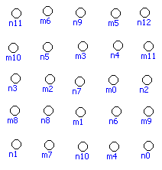

It isn’t complete as it doesn’t verify that there exists a partition {V1, V2} of the set V such that V1 has n vertices, V2 has m vertices, and every vertex of V1 is adjacent to all vertices of V2.

Stéphane Díaz-Alejo León